Coronary Artery Disease Prediction Using PCA-Enhanced SVM Classifier
Swarnasmita Roy^{#RAE23044}, Kaustubh Narayan Kalpathy^{#RAE23054}, Akshaya Gayathri^{#RAE23059}, Indhushree Reddy M^{#RAE23064}
#Department of Mechanical Engineering
Branch of Robotics and Artificial Intelligence
Amrita Vishwa Vidyapeetham
Kasavanahalli, Carmelaram P.O
Bangalore-560035, India
^{RAE23O44}bl.en.u4rae23044@bl.students.amrita.edu
^{RAE23054}bl.en.u4rae23054@bl.students.amrita.edu
^{RAE23059}bl.en.u4rae23059@bl.students.amrita.edu
^{RAE23064}bl.en.u4rae23064@bl.students.amrita.edu

Abstract- CAD, an acronym for coronary artery disease, continues to be one of the leading causes of mortality in the modern world necessitating an effective diagnosis timely. This research focuses on developing a classification model that will be based on machine learning in order to determine the presence of CAD by making use of a dataset of health-related attributes. Reduction of dimensionality of the dataset that provides reasonable computational efficiency without losing essential information is done by Principal Component Analysis (PCA). The work assesses the effectiveness of one classifier SVM (Support Vector Machine) on the dimensionally reduced dataset, with the focused interested regards accuracy, precision, recall and of course F1 score. The focus of this project is to demonstrate the capabilities of machine learning including PCA and SVM in healthcare CAD diagnosis, ensuring its accurate and effective use in a scalable manner to assist clinicians with improving patient outcome and resource management..
Keywords- Coronary Artery Disease (CAD), Principal Component Analysis (PCA), Dimensionality Reduction, Support Vector Machine (SVM), Machine Learning, Heart Disease Classification, Predictive Modeling, Feature Extraction, Supervised Learning, Clinical Decision Support, Model Performance Evaluation, Precision-Recall Analysis, Data Driven Diagnostics.

I.INTRODUCTION
Coronary arteriosclerosis is classified as CAD. It is a disease whereby the coronary arteries which provide blood, oxygen and nutrients to the cardiovascular muscles get blocked or narrowed. In most cases, this narrowing is caused by the buildup of cholesterol, fatty and other substances that become located on the inner walls of arteries.
It is among the major causes of disease burden and mortality all over the world. The actual prevention of the resultant consequences of CAD can be mainly reduced by early diagnosis.
This challenge is addressed afresh in this era of big data and machine learning using PCA and SVM. PCA also contributes toward examining the big data where it retains only the important details with minimal redundancy helped to keep. The extracted feature is then used to predict CAD using SVM and the result is compared with a traditional machine learning technique – the CART tree.
The work then applies PCA and SVM on a predictor data set of heart disease features such as resting blood pressure, cholesterol levels, ages, etc. In order to build a reliable model that can forecast the probabilities of Coronary Artery Disease.

II.PROBLEM STATEMENT

Coronary Artery Disease is a popular area of healthcare concern as the result of numerous causalities and by-products that are usually associated with this illness. While improvements in diagnostic medicine make it easier to deliver diagnostic information, the nature and amount of clinical information make it difficult to detect CAD in an efficient manner. For the most part, traditional diagnostic processes are characterized by sequential analytical steps that are time-consuming and might not yield the correct results.
To achieve a better solution for this condition, the current research employs machine learning approaches. Especially, after conducting feature extraction by using PCA for the dimensionality reduction procedure, we will use an SVM classifier for CAD presence prediction. Such an approach tries to reduce the length of the diagnostic stack and enhance the prediction accuracy to optimize results and the way of delivering healthcare services.

III.LITERATURE REVIEW

Coronary Artery Disease (CAD) is caused by the deposition of a plaque in coronary arteries causing limited blood supply to the heart and can result in heart attacks, strokes, and other cardiovascular problems. Detecting and predicting CAD is of utmost importance to prevent bad consequences, thus CAD has remained at the epicenter in clinical practice and research.

A . Traditional Methods
Some of the traditional clinical tests used in the detection of CAD include Echocardiograms, Electrocardiograms (ECGs), and Angiography. These frequently require well-trained doctors, costly equipment, and a lot of time. Even with all that, they may not always be accurate, especially in the early stages of disease onset.

B. Machine Learning in Healthcare
The ML techniques have been given tremendous attention in the health care sector over the last few years because they could deal with large datasets as well as handle patterns that are very complex to be detected by a human. The various models of Machine Learning - Support Vector Machines, Neural Networks, and Random Forest - have been applied for medical diagnosis purposes like cancer detection, disease prediction, and classification of medical images.

C. Principal Component Analysis (PCA) for Dimensionality Reduction
Dimensionality reduction is an important step in the workflow of most machine learning applications, especially dealing with large datasets that contain many features. PCA has been applied in medical research to reduce the complexity of clinical data and retain important information.

D. Combining PCA and SVM for disease prediction
Several studies have been done on the combination of PCA with SVM for disease predictions. This hybrid combination is advantaging as PCA filters out the redundant variables and reduces the influence of irrelevant features, thus leaving the SVM the process of learning patterns underlying data.
A work by Shamsuddin et al. (2019) applied PCA and SVM to the Cleveland Heart Disease dataset with an accuracy greater than 85%. Applying dimensionality reduction helped an SVM classifier to work more effectively with the model for the prediction of disease likelihood with an improvement in performance and efficiency in computations.

IV.PRINCIPAL COMPONENT ANALYSIS (PCA)

Principal Component is a statistical technique that reduces the dimensionality of a dataset as much as possible without sacrificing too much variance. This technique transforms a high dimensional dataset into a new coordinate system, wherein each axis, known as a principal component, represents one of the directions of maximum variance in the data. This technique is especially useful when dealing with large datasets that have many features, since it simplifies the data without losing important information, thereby enabling easy visualization and analysis of such big data sets.

- Mathematical theory of PCA
The following is a step-by-step mathematical theory used to transform raw data into principal components using PCA, followed by how the entire process works::
- Dataset Standardization: PCA begins by standardizing the data such that all features have the same scale and are zero-centered. This is very fundamental because features may have different units or scales.
Z = (X-µ)/σ
Where,
- Z = Standardized data
- X = Original data matrix
- µ = Mean of each feature
- σ = Standard deviation of each feature

- Computation of Covariance Matrix: The next step is to compute the covariance matrix of the data, which shows how different features relate to each other.
Cov(X) = 1/(n-1) x Z^{T}Z
Where,
- Cov(X) = Covariance matrix
- Z^{T} = Transpose of the standardized data matrix
- n = Number of samples

- Calculate Eigenvalues and Eigenvectors: PCA then calculates the eigenvalues and eigenvectors of the covariance matrix. The eigenvectors represent the directions of principal components, and the eigenvalues indicate how much variance each principal component captures from the data.
Cov(X)v = λv
Where,
- λ = Eigenvalues (represent variance explained by each principal component)
- v = Eigenvectors (represent directions of the principal components)

- Sort Eigenvectors by Eigenvalues: The eigenvalues are sorted in descending order:
λ1​≥λ2​≥ λ3…..≥λp​
The top k eigenvectors are chosen corresponding to the largest k eigenvalues to form the projection matrix
V_{k =} [v_{1,} v_{2,} v₃,…,v_{k}]

- Projection onto Principal Components: At this step, we transform the standardized data Z into the new k- dimensional subspace.
Z_{k} = ZV_{k}
Where,
- Z_{k} = Data projected onto k-dimensional subspace
- V_{k} = Matrix of selected k eigenvectors

The result is a new dataset where each dimension corresponds to a principal component.
This projection transforms the data into a lower-dimensional space, effectively creating the principal components while preserving as much information as possible.

- Variance Calculation: Calculate the proportion of variance explained by each principal component
Variance = λ_{i} /(^{p}∑_{j=1} λ_{j}) x 100
- λ_{i} = Eigenvalue associated with the i-th principal component
- ^{p}∑_{j=1} λ_{j} = Sum of all eigenvalues, representing the total variance in the dataset.
- P = Total number of principal components
The Variance explained by the principal components determines how much of the original dataset’s variability is captured by each principal component. It provides a measure of the importance of each component in representing the data

Cumulative Variance is calculated to determine the number of components needed:
Cumulative Variance = ^{i}∑_{j=1} (λ_{j}/ (^{p}∑_{j=1} λ_{j})) x 100
Where,
^{p}∑_{j=1} λ_{j} = Sum of eigenvalues up to the i-th principal component.
The Cumulative Variance helps to determine how many principal components are required to capture a desired percentage of the total variance (e.g., 75% or 85% ).

- Collection of Dataset
The dataset used for this study is taken from a public source , concentrating on patients with Coronary Artery Disease. This contains 1,025 entries with clinical Parameters that contribute to diagnosis and risk evaluation in patients with CAD.
The features of the dataset are age, sex, chest pain type (cp), resting blood pressure (trestbps), serum cholesterol (chol), fasting blood sugar (fbs), resting electrocardiographic results (restecg), maximum heart rate achieved (thalach), exercise-induced angina (exang), ST depression induced by exercise relative to rest (oldpeak), slope of the peak exercise ST segment (slope), number of major vessels (ca), Thalassemia (thal) which is an inherited blood disorder, diagnosis of heart disease (target)

- Implementation of PCA in MATLAB for CAD data
In conditions like Coronary Artery Disease (CAD), where multiple clinical factors such as age, cholesterol, resting blood pressure etc contribute to diagnosis and treatment, PCA helps by transforming the data into a smaller set of uncorrelated components. These components capture the most significant patterns in the data to make it easier to identify key risk factors and optimize treatment plans.
After collecting a suitable dataset, the steps to be followed in MATLAB are :
- Loading and Preprocessing the Data
- This step involves loading the dataset from a CSV file using readtable with the appropriate import options.
- The data is then converted into a numerical array using table2array for further analysis.

Code snippet :
% Load the data
Opts=detectImportOptions("C:\Users\SWARNASMITA\OneDrive\Documents\heart.csv");
data=readtable("C:\Users\SWARNASMITA\OneDrive\Documents\heart.csv", opts);
% Convert table to array for numerical operations
dataArray = table2array(data);

- Standardizing the data
- The dataset is standardized (mean = 0, standard deviation = 1) to ensure that all features contribute equally, regardless of their scale.
- The zscore function is used to standardize the data.
Code Snippet :
% Standardize the data (zero mean and unit variance)
standardizedData = zscore(dataArray);
% Update the data table with standardized values
data{:, vartype('numeric')} = standardizedData;

- Computing the Covariance Matrix
- The covariance matrix is calculated from the standardized data to capture the relationships between the features
- The covariance matrix is essential for identifying how the data varies and correlates.
Code Snippet :
% Compute covariance matrix
covMatrix = cov(standardizedData)

- Calculation of Eigenvalue and Eigenvector
- Eigenvalues and eigenvectors are computed from the covariance matrix using the eig function.
- Eigenvalues represent the amount of variance explained by each principal component, on the other hand eigenvectors define the direction of these components
Code Snippet:
% Calculate eigenvalues and eigenvectors
[eigenVectors, eigenValuesMatrix] = eig(covMatrix);
eigenValues = diag(eigenValuesMatrix);

- Sorting Eigenvalues and Eigenvectors
- The eigenvalues are sorted in descending order, and the eigenvectors are rearranged with respect to the corresponding eigenvalue
- This is necessary as we want to keep the components that explain the most variance.
Code Snippet:
% Sort eigenvalues in descending order (important for PCA)
[eigenValuesSorted, indices] = sort(eigenValues, 'descend')
sortedEigenVectors = eigenVectors(:, indices); % Sorted eigenvectors

- Variance Explained by each principal component
- The variance explained helps in identifying how much information each component captures from the dataset.
Code Snippet:
% Calculate the percentage of variance explained by each component
varianceExplained=(eigenValuesSorted/sum(eigenValuesSorted)) * 100;

- Scree Plot for visualizing Variance Explained
- A scree plot is created to visually assess the explained variance for each principal component. This helps to decide how many components to keep for further analysis.
Code Snippet:
% Plotting a scree plot of the explained variances for each component
figure;
bar(varianceExplained);
xlabel('Principal Component');
ylabel('Percentage of Variance Explained');
title('Scree Plot of Explained Variances');
grid on;

- Projecting the data onto principal components
- The data is projected onto the peincipal components i.e selected eigenvectors to reduce its dimensionality.
- The top k eigenvectors are used to define the new subspace.
Code Snippet:
% Select the top k eigenvectors (e.g., top 8 components)
k = 8; % Number of principal components to keep
principalComponents = sortedEigenVectors(:, 1:k);
% Project the standardized data onto the new subspace
projectedData = standardizedData * principalComponents

- Construct and Analyze the Loadings table
- Using the sorted eigenvectors, loadings for the top k principal components are extracted.
- These loadings are organized into a table, associating each feature with its contribution to each principal component
Code Snippet:
% Create a table for loadings along with feature names
loadings = sortedEigenVectors(:, 1:k); % Loadings for the top k components
columnNames = data.Properties.VariableNames; % Get the feature names
loadingTable = table();

- Visualizing the projection
- A scatter plot is used to visualize the data after projection onto the first two principal components
Code Snippet:
% Plot the first two components (you can modify this to use more components)
figure;
scatter(projectedData(:, 1), projectedData(:, 2), 30, labels, 'filled');
colormap(jet); % Color scheme for variety
colorbar; % Show color scale if you're using labels
xlabel('Principal Component 1');
ylabel('Principal Component 2');
title('PCA Projection using First Two Components');
grid on;

- Biplot for understanding Component loadings
- A biplot is created to visualize both the data projections and the loadings of the features on the principal components. This shows how the features contribute to each principal component.
Code Snippet:
% Use the first two principal components for biplot
biplot(loadings(:, 1:2), 'Scores', projectedData(:, 1:2), 'VarLabels', columnNames);
xlabel('Principal Component 1');
ylabel('Principal Component 2');
title('Biplot of the First Two Principal Components');
grid on;

- Displaying top features based on loadings
- The top features for each principal component are identified by sorting the loadings.
Code Snippet:
% Show the features that have the highest loadings for the first 2 principal components
for i = 1:2 % Show top features for the first 2 components
[~, sortedIdx] = sort(abs(loadings(:, i)), 'descend'); % Sort by absolute value of loadings
fprintf('\nTop features for Principal Component %d:\n', i);
for j = 1:2 % Display top 2 features for each component
fprintf('%s (Loading: %.4f)\n', columnNames{sortedIdx(j)}, loadings(sortedIdx(j), i));
end
end

- Cumulative Variance Plot
- A cumulative plot is generated to visualize how much total variance is explained by increasing numbers of principal components.
Code Snippet:
% Cumulative variance plot
cumulativeVariance = cumsum(varianceExplained);
figure;
plot(cumulativeVariance, '-o');
xlabel('Number of Principal Components');
ylabel('Cumulative Variance Explained (%)');
title('Cumulative Variance Explained by Principal Components');
grid on;

- Determining the number of components to achieve the desired variance
- The number of components needed to reach a specified cumulative variance threshold (75%) is computed.
Code Snippet:
% Find the number of components to reach a chosen variance threshold
threshold = 75; % Desired cumulative variance threshold (e.g., 75%)
num_components = find(cumulativeVariance >= threshold, 1);

- Interpretation of Results
- Standardized dataset

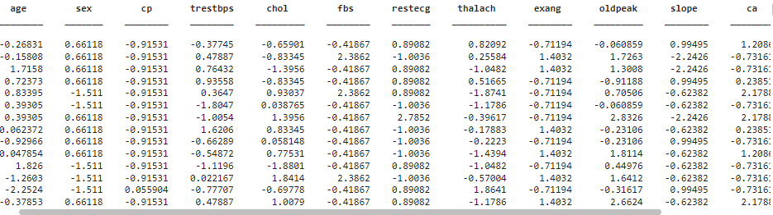
Fig 1.Standardized dataset

Each feature in the dataset was scaled so that it has a mean of 0 and a standard deviation of 1. This step eliminates any bias introduced because of varying magnitudes of features, thus making the dataset compatible with PCA and other machine learning methods.

- Covariance Matrix
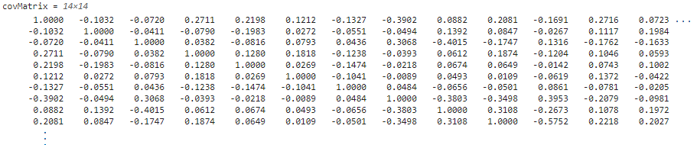
Fig 2. Covariance matrix

It represents covariance between the two features if each entry of the matrix is computed, and diagonal entries are the variance of individual features.
- Diagonal Entries (Variance)- All diagonal elements are 1 because of standardization which means each feature has unit variance.
- Off- Diagonal Entries (Covariance)- Positive values indicates that the features increase/decrease together (Positive Correlation)
Negative values indicates that a feature increases while the other decreases (Negative Correlation).

- Eigenvalues and Variance
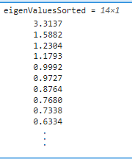

Fig 3. Eigenvalues

The sorted eigenvalues explain how much variance each principal component explains. Here, larger values donate components with more information, while the smaller ones carry less, which will help prioritize how many to retain in dimensional reduction.

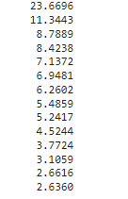
Fig 4. Variances

The first few components explain the most variance. This can be used to reduce the dimensions while preserving most of the data’s information.

- Scree Plot
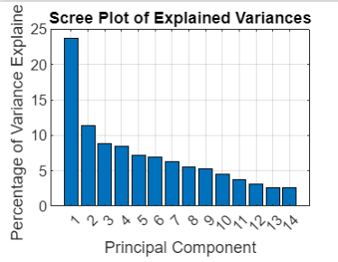
Fig 5. Scree Plot

In this plot, each bar height represents the percentage of variance that each principal component explains, helping to visualize how much information each component contributes.

- Projection of data
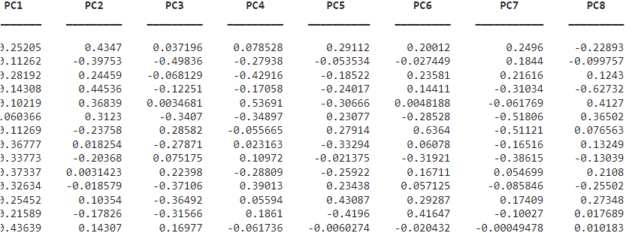
Fig 6: Projected data

The top 8 components capture the most significant variance in the data.

- Scatter Plot
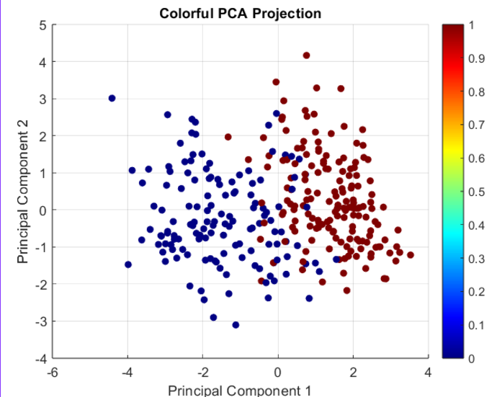
Fig 7. Scatter Plot

This scatter plot visualizes data distribution in the first two principal components. Each point is a sample from the data, and colors denote different class labels.

- Biplot of the first 2 principal components
The biplot combines the scores of observations with loadings of variables so that one can try to understand clustering, variable contributions, and data structure.
Points that lie close together refer similar patterns, outliers differ. Variable vectors reflect contributions to principal components: the direction indicates influence, and the length shows the strength. The angle between the vectors expresses the correlations among variables: acute for positive, right for none and obtuse for negative ones. The long vectors help interpret the components like risk factors for health for eg., age, cholesterol, blood pressure etc.
Overall, this biplot has effectively summarized data structure showing how well the first two components capture variance.

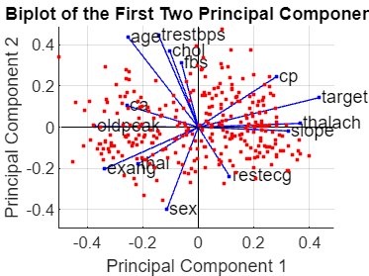

Fig 8. Biplot of first 2 principal components

- Cumulative Variance Plot

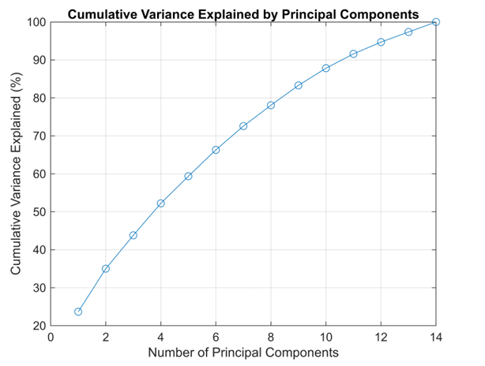
Fig 9. Cumulative Variance plot

This plot is used to decide how many principal components to keep , balancing simplicity and retention of information.
In our case, we are considering a variance threshold to be 75% and the number of components required to reach that level is 8.

- Top features from 8 components
From this output it can be inferred that the most important features that can be considered as major major health factors are :
- Blood Pressure – Reflects the overall condition of one’s cardiovascular system
- Cholesterol – Elevated levels are associated with fatty deposits on the walls of arteries, thus puts someone at risk for developing heart disease
- Chest Pain – Specific in nature, helps a doctor to doctor identify angina versus another problem
- Age – Important risk factor because older people are more prone to cardiovascular disease
- Thalassemia – A disorder in the blood that can interfere with oxygen transport and therefore heart function
- No. of major vessels – Number of narrowed or blocked vessels affecting blood flow and level of risk
- Oldpeak – Provides estimation for severity of ischemia (condition characterized by reduced blood flow to a specific part of the body)
- Restecg – Represents the results of echocardiography

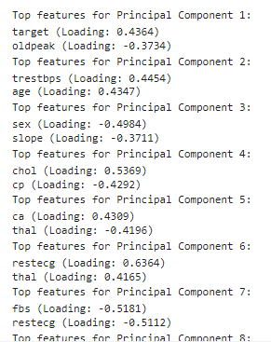
Fig 10. Top features of each component

Overall, the PCA effectively reduced the dimensions of the data, retained the important features and delivered important conclusions of major factors, leading to a more efficient and accurate analysis for predicting heart disease.

V. SUPPORT VECTOR MACHINE (SVM)
A. A brief look at Support Vector Machines (SVM)
Support Vector Machine (SVM) is an intelligent learning method that belongs to supervised learning techniques and it
Focused on solving classification and regression problems. It based on the concept of being able to find the hyperplane in the multi-dimensional space that will give the biggest margin between the classes of the data samples. The Key characteristics of SVM include:
- Versatility: Work well with both, linear and non-linear classification problems.
- Robustness: Best used where the data involved has many dimensions.
- Generalization: Being concerned with the support vectors (boundary data), that is undoing.
For instance, is a classification function that involves two categories, if the pattern in each category can be separated by a linear function, then SVM furnishes an estimate of a hyperplane and the nearest of the class data points being greater than margin. The above model has several advantages over the previous models, particularly because of the margin based strategy and be able to handle a small difference as what is found in the training data set .

B. SVM Algorithm Overview
1. PCA for Dimensionality Reduction
- In our dataset, we first reduce the features in order to focus on the most important components and also get rid of some variance using PCA (Principal Component Analysis). This basically reduces the complexity of the data and makes SVM efficient to perform in low-dimensional space.

2. Model Initialization
- We start with an SVM classifier using a linear kernel, which is appropriate if the data are linearly separable in PCA-reduced feature space.
- The parameter class_weight='balanced' deals with imbalance in the distribution of training data classes, by changing weights to be inversely proportional to class frequencies.

3. Hyperparameter Optimization
- Hyperparameter tuning of the SVM model is carried out with GridSearchCV, using different values for regularization parameter C and kernel parameter gamma.
- This helps to ensure that the code overfits and the best parameters generalize well when they see unseen data, thereby reducing robustness.

4. Training and Prediction
- This creates a classifier which is trained on the training dataset along with the best parameters we found using grid search.
- It learns a decision hyperplane in PCA reduced space for class separation. This hyperplane is then used to make predictions on the test dataset.

5. Performance Evaluation
- We evaluate the predictions from our model using important metrics like accuracy, confusion matrix, classification report, ROC curve, and precision-recall curve.
- Confidence scores for these metrics are computed via the SVM decision function.

6. Visualizing Decision Boundary
- The classes are separated in the reduced feature space where this is plotted as a 2D decision boundary.
- This gives an intuitive background about how the SVM model is classifying data points as well as helps us realize that wavering classes can be linearly separated very well.

This implementation illustrates optimal classification result using SVM on a high dimensional dataset with the aid of dimensionality reduction, hyperparameter tuning and extensive model evaluation.

C. Kernel Functions in SVM
Kernel functions are essential part of SVM that becomes very important when your data is not linearly separable in its initial feature space. Here we use a linear kernel, which is computationally efficient and suitable for any dataset that has been made linearly separable using PCA.

1. Purpose of Kernel Functions
- Kernel functions map the data into high dimensional spaces, allowing SVM to find a hyperplane that separates them.
- Various kernel types—polynomial, radial basis function (RBF), sigmoid—are appropriate to different data distributions and complexity.

2. Linear Kernel Used In This Implementation
- The linear kernel is literally just a dot product, as in a basic feature vector, so this would be quite slow on anything other than trivial datasets that have already been pre-processed by PCA
- It sidesteps unnecessary complexity and retains interpretability & computational efficiency of the model.

3. Considerations Related to Performance and Scalability
- While kernels such as RBF provide a flexible solution to high dimensional datasets, here we achieve the balance of computational efficiency and recyclable accuracy through a simple linear kernel on PCA-reduced space.

This implementation achieves a middle ground between simplicity and performance by utilizing the linear kernel (the simplest) with PCA to make the dataset linearly separable.

D. Advantages of Combined PCM and SVM
PCA and SVM have many benefits when are combined together, especially for high-dimensional data (used in our implementation).

1. Dimensionality Reduction
- PCA reduces the number of features while keeping most of the variance. This makes the data less complex and reduces overfitting especially if there are a small number of samples in the training set.

2. Noise Reduction and Redundancy Removal
- Inevitably, the SVM could be considered to focus on only the most essential patterns for classification by denoising and removing redundancy intrinsically via projecting data in lower-dimensional space through PCA.

3. Improved Efficiency:
- As the computational complexity increases with dimensions, SVM run faster and more efficient in the small feature space.

4. Robustness Against Multicollinearity
- PCA is a solution for high-dimensional datasets that often encounter multicollinearity (correlated features) by creating orthogonal principal components on which regression can now be applied.

5. Improved visualisation and interpretation ability
- You can visualize the separation of classes with a 2D decision boundary after reducing the dataset to two or three dimensions; this is what was done in this implementation.

6. Improved Generalization of Model:
- At the same time, PCA serves to make sure that SVM is able to generalize well on unseen data since principal components are those directions in feature space which usually represent patterns which tend to persist on test data as well.

This python implementation of PCA + SVM makes use of the strengths provided by both techniques under their chosen framework to generate a classifier which is not only accurate, but also computationally efficient and interpretable.

